May9 Trading

Monday, May 09, 2016

Need to decide whether to sell here. Always sell some when market going up. Use uncertainty to your advantage.

|  |  |  |  |  |  |  |  |  |  |  |  |
| --- | --- | --- | --- | --- | --- | --- | --- | --- | --- | --- | --- |
| W | Ycat | retAM | retPM | shortAM | longAM | shortPM | longPM | AM | PM | AMMax | PMMax |
| 1 | [0,0.226] | -0.0024 | 0.0006 | 1.68 | 0.58 | 0.87 | 1.12 | s | **l** | 1.68 | 1.12 |
| 1 | (0.226,0.6] | -0.0015 | 0.0013 | 1.21 | 0.8 | 0.87 | 1.12 | s | **l** | 1.21 | 1.12 |
| 1 | (0.6,0.905] | 0.0011 | 0.0012 | 0.81 | 1.21 | 0.83 | 1.19 | l | **l** | 1.21 | 1.19 |
| 1 | (0.905,1] | 0.001 | 0.0024 | 0.73 | 1.35 | 0.7 | 1.42 | l | **l** | 1.35 | 1.42 |
| 2 | [0,0.226] | -0.0003 | 0.0039 | 1.02 | 0.96 | 0.37 | 2.61 | **s** | l | 1.02 | 2.61 |
| 2 | (0.226,0.6] | -0.0003 | 0.0018 | 1.04 | 0.95 | 0.79 | 1.25 | **s** | l | 1.04 | 1.25 |
| 2 | (0.6,0.905] | -0.002 | 0.0011 | 1.31 | 0.75 | 0.96 | 1.02 | **s** | l | 1.31 | 1.02 |
| 2 | (0.905,1] | -0.0002 | 0.0004 | 1.23 | 0.8 | 1.28 | 0.76 | **s** | s | 1.23 | 1.28 |
| 3 | [0,0.226] | -0.0001 | 0.0025 | 0.96 | 1.03 | 0.52 | 1.88 | l | l | 1.03 | 1.88 |
| 3 | (0.226,0.6] | -0.0004 | 0.0026 | 1.18 | 0.84 | 0.56 | 1.75 | s | l | 1.18 | 1.75 |
| 3 | (0.6,0.905] | -0.0002 | 0.0007 | 0.71 | 1.38 | 1.01 | 0.97 | l | s | 1.38 | 1.01 |
| 3 | (0.905,1] | -0.0001 | 0.0007 | 0.91 | 1.08 | 1.17 | 0.84 | l | s | 1.08 | 1.17 |
| 4 | | [0,0.226] | -0.0015 | 0.0015 | 1.3 | 0.76 | 0.63 | 1.54 | **s** | l | 1.3 | 1.54 |
| 4 | (0.226,0.6] | -0.0011 | 0.0006 | 1 | 0.98 | 0.83 | 1.18 | **s** | l | 1 | 1.18 |
| 4 | (0.6,0.905] | -0.0008 | -0.0016 | 0.99 | 0.99 | 1.31 | 0.75 | **l** | s | 0.99 | 1.31 |
| 4 | (0.905,1] | 0.0002 | -0.0012 | 1.05 | 0.93 | 1.82 | 0.54 | **s** | s | 1.05 | 1.82 |
| 5 | [0,0.226] | -0.0001 | 0.0013 | 0.99 | 0.99 | 0.64 | 1.51 | l | l | 0.99 | 1.51 |
| 5 | (0.226,0.6] | -0.0003 | 0.0012 | 0.89 | 1.1 | 0.7 | 1.4 | l | l | 1.1 | 1.4 |
| 5 | (0.6,0.905] | -0.0001 | 0.0007 | 1.08 | 0.92 | 1.05 | 0.94 | s | s | 1.08 | 1.05 |
| 5 | (0.905,1] | -0.0001 | 0 | 0.99 | 0.99 | 1.01 | 0.98 | l | s | 0.99 | 1.01 |

Takeaway from this table:

PM return is correlated with closing percentile of T-1, applies to Wed, Thu, Fri.

With such a weak Friday, the expected return this morning is negative.

Apparently probability speaking, the AM session is negative from Friday's after effect. The early sell was good.

Today's morning is the weakest scenario of all. Monday following a weak Friday.

Weak first1, first10 -> no buying today.

|  |  |  |  |  |  |
| --- | --- | --- | --- | --- | --- |
| weekday | amFirst5Cat | med | len | cumlong | cumshort |
| **1** | **[-0.0248,-0.0017]** | **-0.0006** | **239** | **0.81** | **1.2** |
| 1 | (-0.0017,3e-05] | 0.0005 | 176 | 1.1 | 0.9 |
| 1 | (3e-05,0.00161] | 0.0017 | 183 | 1.32 | 0.75 |
| 1 | (0.00161,0.0343] | 0.0036 | 195 | 1.79 | 0.54 |
| **2** | **[-0.0248,-0.0017]** | **-0.0002** | **208** | **0.92** | **1.05** |
| 2 | (-0.0017,3e-05] | 0.001 | 205 | 1.12 | 0.88 |
| 2 | (3e-05,0.00161] | 0.0016 | 199 | 1.37 | 0.72 |
| 2 | (0.00161,0.0343] | 0.0027 | 205 | 1.81 | 0.53 |
| 3 | [-0.0248,-0.0017] | 0.0007 | 192 | 1.08 | 0.91 |
| 3 | (-0.0017,3e-05] | 0.0014 | 214 | 1.09 | 0.9 |
| 3 | (3e-05,0.00161] | 0.001 | 218 | 1 | 0.98 |
| 3 | (0.00161,0.0343] | 0.0028 | 192 | 2.28 | 0.42 |
| **4** | **[-0.0248,-0.0017]** | **-0.0013** | **220** | **0.67** | **1.44** |
| **4** | **(-0.0017,3e-05]** | **-0.0013** | **223** | **0.74** | **1.32** |
| **4** | **(3e-05,0.00161]** | **-0.001** | **199** | **0.96** | **1.03** |
| 4 | (0.00161,0.0343] | 0.0022 | 173 | 1.55 | 0.63 |
| **5** | **[-0.0248,-0.0017]** | **-0.0017** | **154** | **0.88** | **1.12** |
| 5 | (-0.0017,3e-05] | 0.0012 | 194 | 1.23 | 0.8 |
| 5 | (3e-05,0.00161] | 0.0012 | 213 | 1.15 | 0.86 |
| 5 | (0.00161,0.0343] | 0.0012 | 248 | 1.57 | 0.62 |

Colored rows are shortable scenarios. Today's afternoon is not safe. -> don't trade. It seems that I should have given it the benefit of the doubt and liquidate the position this morning.

Was Friday trading all correct? 🡪 Look into this.

Futures are testing today's low.

From Jan-Mar, there was not a single big loss. The loss on Apr 20 was due to selling in panic at the day's lowest level.

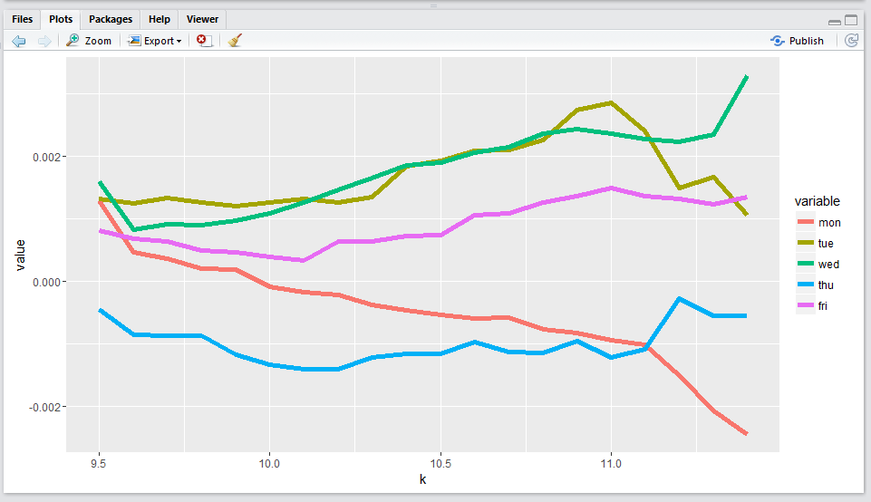

The above graph depicts how amMin affects pm return. Monday is affected the worst. For Wednesday a weak AM actually makes PM stronger.

Note for Monday that a low after 10 makes the afternoon return negative.

For Wednesday and Friday a weak AM session increases the PM performance.

Thursday it is all negative.

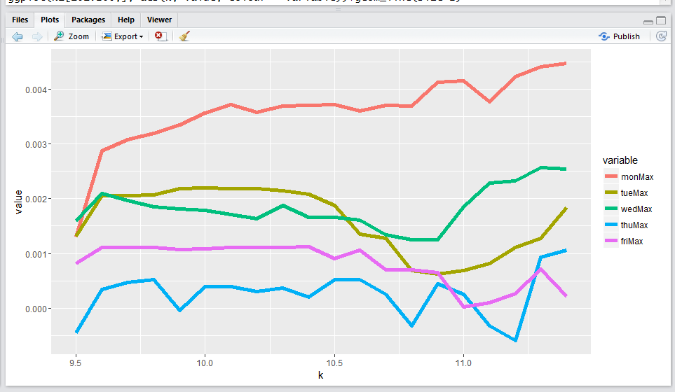

The above diagram depicts how amMax affects the retPMCO. Monday's pm is affected linearly.

The line for Tuesday and Wednesday are interesting.

Unconditionally, wed > mon > tue > fri > thu.

For Tuesday, highs after 10:30 actually reduce afternoon returns.

Tuesday, May 10, 2016

You need to follow operating principles. Yesterday's am session was supposed to be shorted. The losses suffered thereof was a result of not following the rules.

Yesterday evening session I was almost going to buy 1 lot at the day's low, but I refrained from doing so. As per research, Tuesday morning has a negative return and since already 30% of the portfolio is on, you have very little flexibility remaining which needs to be used at the most critical time.

The losses recently was due to adding position too early, cannot handle the worst case scenario with a big position,

1. not knowing the probability distribution (this happened when I was buying on the way down on Thursday when Wednesday closed at the highs)
2. Position is too big such that the damage of a unlikely event is so great which causes risk aversion (when potential unlikely losses are sizable, would rather lock in the losses). Big position causes risk aversion. Casino never risks too much of the capital in one bet.
3. Knowing the expected return of the session but unable to follow through with the correct procedure due to mental reasons.

XU opens 1.2% discount. Market is volatile and I am not going to add position here. Today's advantage is in the PM. Today's expected return is positive.

|  |  |  |  |  |  |  |  |  |  |  |
| --- | --- | --- | --- | --- | --- | --- | --- | --- | --- | --- |
| w | | pcty | | day | | | am | | pm | |
| 1 | | [0,0.226] | | -0.0002 | | | -0.0024 | | 0.0006 | |
| 1 | | (0.226,0.6] | | 0.0005 | | | -0.0015 | | 0.0013 | |
| 1 | | (0.6,0.905] | | 0.0025 | | | 0.0011 | | 0.0012 | |
| 1 | | (0.905,1] | | 0.0029 | | | 0.001 | | 0.0024 | |
| 2 | | [0,0.226] | | 0.0044 | | | -0.0003 | | 0.0039 | |
| 2 | | (0.226,0.6] | | 0.0016 | | | -0.0003 | | 0.0018 | |
| 2 | | (0.6,0.905] | | -0.0008 | | | -0.002 | | 0.0011 | |
| 2 | | (0.905,1] | | 0.0001 | | | -0.0002 | | 0.0004 | |
| 3 | | [0,0.226] | | 0.0028 | | | -0.0001 | | 0.0025 | |
| 3 | | (0.226,0.6] | | 0.0024 | | | -0.0004 | | 0.0026 | |
| 3 | | (0.6,0.905] | | -0.0001 | | | -0.0002 | | 0.0007 | |
| 3 | | (0.905,1] | | -0.0002 | | | -0.0001 | | 0.0007 | |
| 4 | | [0,0.226] | | 0.0012 | | | -0.0015 | | 0.0015 | |
| 4 | | (0.226,0.6] | | 0.0002 | | | -0.0011 | | 0.0006 | |
| 4 | | (0.6,0.905] | | -0.0018 | | | -0.0008 | | -0.0016 | |
| 4 | | (0.905,1] | | -0.0011 | | | 0.0002 | | -0.0012 | |
| 5 | | [0,0.226] | | 0.0018 | | | -0.0001 | | 0.0013 | |
| 5 | | (0.226,0.6] | | 0.0011 | | | -0.0003 | | 0.0012 | |
| 5 | | (0.6,0.905] | | -0.0003 | | | -0.0001 | | 0.0007 | |
| 5 | | (0.905,1] | | -0.0005 | | | -0.0001 | | 0 | |
| w | pcty | | amminT | | ammax | pmmin | | pmmax | daymin | dmax | | ddiff | amdif | pmdif |
| 1 | [0,0.226] | | 10.36 | | **9.79** | 13.88 | | 14.1 | 11.5 | 10.09 | | -1.44 | -0.68 | 0.46 |
| 1 | (0.226,0.6] | | 10.27 | | 10.13 | 14 | | 14.1 | 11.18 | 10.9 | | -1.03 | -0.48 | 0.5 |
| 1 | (0.6,0.905] | | 10 | | 10.43 | 13.95 | | 14.12 | 10.47 | 13.07 | | **1.57** | 0.52 | 0.58 |
| 1 | (0.905,1] | | 10.08 | | 10.17 | 13.63 | | 14.3 | 10.42 | 13.82 | | **3.35** | 0.07 | **0.87** |
| 2 | [0,0.226] | | 10.42 | | 10.01 | 13.68 | | 14.35 | 11.22 | 13.25 | | **1.25** | -0.43 | **0.88** |
| 2 | (0.226,0.6] | | 10.32 | | 10.02 | 13.8 | | 14.08 | 11.13 | 11.02 | | 0.62 | -0.57 | 0.57 |
| 2 | (0.6,0.905] | | 10.39 | | 10.13 | 13.92 | | 14.26 | 13.11 | 10.62 | | -0.96 | -0.57 | 0.68 |
| 2 | (0.905,1] | | 10.38 | | 10.09 | 13.99 | | 14.03 | 12.23 | 10.95 | | -0.7 | -0.55 | -0.31 |
| 3 | [0,0.226] | | 10.4 | | **9.98** | 13.75 | | 14.18 | 13.08 | 11.02 | | -0.73 | -0.58 | 0.6 |
| 3 | (0.226,0.6] | | 10.5 | | 10.17 | 13.78 | | 14.37 | 11.33 | 11.3 | | 0.68 | -0.55 | 0.8 |
| 3 | (0.6,0.905] | | 10.18 | | 10.46 | 14 | | 14.14 | 12.27 | 11.08 | | -0.88 | 0.52 | 0.34 |
| 3 | (0.905,1] | | 10.14 | | 10.3 | 14.12 | | 13.96 | 12.25 | 13.07 | | -0.6 | 0.37 | -0.46 |
| 4 | [0,0.226] | | 10.57 | | **9.99** | 13.88 | | 14.2 | 13.19 | 11.07 | | -0.24 | -0.68 | 0.6 |
| 4 | (0.226,0.6] | | 10.42 | | 10.12 | 14.12 | | 14 | 11.33 | 10.82 | | 0.4 | -0.58 | -0.33 |
| 4 | (0.6,0.905] | | 10.25 | | 10.27 | 14.28 | | 13.93 | 13.56 | 10.77 | | **-1.77** | -0.39 | **-0.73** |
| 4 | (0.905,1] | | 10.27 | | 10.3 | 14.3 | | 13.9 | 13.2 | 11.02 | | -0.95 | 0.07 | -0.68 |
| 5 | [0,0.226] | | 10.6 | | 10.01 | 14.07 | | 14.07 | 11.36 | 11.2 | | -0.43 | -0.63 | 0.46 |
| 5 | (0.226,0.6] | | 10.37 | | 10.22 | 13.89 | | 14.02 | 11.42 | 11.08 | | 0.61 | -0.33 | 0.57 |
| 5 | (0.6,0.905] | | 10.44 | | 10.24 | 14.01 | | 14.13 | 12.25 | 10.88 | | -0.81 | -0.32 | 0.56 |
| 5 | (0.905,1] | | 10.37 | | 10.2 | 14.05 | | 13.97 | 11.33 | 13.02 | | -0.52 | -0.37 | -0.43 |

The above shows us that am is weak in all scenarios, and afternoon will be stronger.

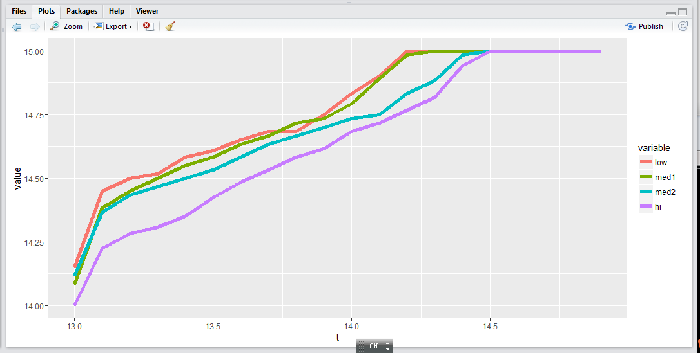

This diagram shows that percentileYCat has a negative relationship with the strength of the conditional pm max. Yesterday was weak, so as soon as pm shows strength it is considered a noteworthy strength. Raising past 14.

Markets are strong this AM session. After

percentileYCat amClosePercentileCat pmax pmin diff

1 [0,0.226] [-0.142,0.197] 14.60000 13.51667 1.0333338

2 [0,0.226] (0.197,0.492] 14.70000 13.40000 1.1833334

3 [0,0.226] (0.492,0.793] 14.31667 13.75000 0.7333336

**4 [0,0.226] (0.793,1.13] 13.41667 14.15000 -0.6999998**

5 (0.226,0.6] [-0.142,0.197] 14.11667 13.90000 0.4333334

6 (0.226,0.6] (0.197,0.492] 14.20000 13.78333 0.5833330

7 (0.226,0.6] (0.492,0.793] 14.01667 13.90000 0.5833330

8 (0.226,0.6] (0.793,1.13] 14.00000 13.72500 0.6083164

9 (0.6,0.905] [-0.142,0.197] 14.26667 13.92500 0.6166668

10 (0.6,0.905] (0.197,0.492] 14.20000 13.90000 0.6500006

11 (0.6,0.905] (0.492,0.793] 14.50000 14.08333 0.6999998

12 (0.6,0.905] (0.793,1.13] 14.13333 13.75000 0.8250003

**13 (0.905,1] [-0.142,0.197] 14.02500 14.26667 -0.5333333**

14 (0.905,1] (0.197,0.492] 14.26667 13.73333 0.8333330

**15 (0.905,1] (0.492,0.793] 13.91667 14.14167 -0.3583336**

**16 (0.905,1] (0.793,1.13] 13.65000 13.98333 -0.5166664**

> e1s[,c(1,2,14,15)]

w t maxxAMH.YL minxAMH.YL

21 2 13.0 13.41667 14.01667

22 2 13.1 14.70000 14.21667

23 2 13.2 14.87500 14.21667

24 2 13.3 14.87500 14.21667

25 2 13.4 14.87500 14.26667

26 2 13.5 15.00000 14.30833

27 2 13.6 15.00000 14.36667

28 2 13.7 15.00000 14.41667

29 2 13.8 15.00000 14.45000

30 2 13.9 15.00000 14.56667

31 2 14.0 15.00000 14.61667

32 2 14.1 15.00000 14.63333

33 2 14.2 15.00000 14.63333

34 2 14.3 15.00000 14.70000

35 2 14.4 15.00000 14.73333

36 2 14.5 15.00000 14.75000

37 2 14.6 15.00000 14.84167

38 2 14.7 15.00000 14.88333

39 2 14.8 15.00000 14.88333

40 2 14.9 15.00000 14.95000

Unconditional min is later than the max, but as

PmMax is either at the beginning or at the end. If the high breaks here, then the median will be at 15:00 pm.

Realized whole 3k of loss.

Bought @ 9302. The median of the pmMax is at the end of the session.

Wed

US performed strongly overnight.

Markets are quite scared of what happened last Wednesday. The open is not that strong. Quickly selling 50 bps.

50bps discount in the morning.

60 bps discount.

Offshore futures are scared. Typical AM weakness.

Markets are very cautious and noone wants to buy, knowing the weakness of the AM session.

Shift into short if after 10am if it still goes down.

Market is risk averse.

Trade according to the first 5 minute performance.

Back to 1 lot. Recently strategies are changing a bit. Don't add position.

80bps of trading PNL loss. Be careful now. Only use light positioning. Essentially, keeping a short position at a 60 bps discount is not a very wise thing to do.

Problem with today's trading:

The short position was put on a little bit late at a big discount. Let's see how this position gets destroyed and try to learn some lesson from it.

The buying in the morning – does it make sense? It cost 80. The situation was not clear. I did not want to miss out on the possible rally.

Today's trading:

Bought 1 lot, hoping that the market would go up.

* AM median return is positive, given Wednesday. Ammax would come after ammin. Pmmin would come after pmmax.

Sold 3 lots. Rationale: low was broken. Conditional min would have the median around 11.

* AM is actually expected to be strong and PM is expected to be a gamble.

I doubt what you did is correct given today's Wednesday. Investigate more into this.

Avoid all position build-up now. Focus on fundamentals.

The weak 5 min would reflect through.

What did you do wrong today? What did you do right today?

When you short, you need to pick a competitive level. The shorting decision was based on conditional median.

用交易来暴露一些弱点是很有必要的. 第一单,买入.

5.12.2016

Yesterday's issues include:

1. First position was bought too early. (without justification). You should always wait until retreat to buy.
2. Sell was at the lows at the same time. Selling should have been more spaced out instead of all at once. Also, selling should be done on the rebound instead of on the way lower.
3. Situation usually becomes clearer towards the later of the session. Use amFirst5 as a reference
4. [Position Building] Build position little by little. Avoid yesterday's selling all position at once and switching into short -> was a bit rash.
5. Short in the morning unless yesterday closed at the absolute lows.

Yesterday's closing percentile is negative correlated with today's retPMCO.

First 5 minute is very weak.

Today both the expected return for AM and PM is negative, short into the close.

First 5 dropped very heavily. Trade in accordance with the first 5.

无序波动的状态下, 用amFirst1+amFirst5作为参考.

[11:05]Markets are very strong. However, median for Tuesday with a weak amFirst is negative. Keep this position until the close.

Following rules are important. In addition, trading needs to take place at places where market participants do not know what to do. In a probability vacuum on the market side, whoever knows probability better will have an edge.

The following table is the relationship between amClosePercentile and percent of max>min.

[0,0.2] (0.2,0.5] (0.5,0.8] (0.8,1]

1 0.40 0.54 0.59 0.66

2 0.56 0.63 0.53 0.51

3 0.57 0.53 0.49 0.54

4 0.48 0.48 0.43 0.48

5 0.58 0.53 0.49 0.51

Monday: afternoon strength is linear with the amClosePercentile.

Tuesday/Wednesday: a weak AM session helps more with the pm rebound, whereas a strong AM sometimes hurts the PM.

Thursday: generally weak in all scenarios.

Friday: a weak AM session helps with PM rebound. If AM strong PM is gamble.

[0,0.2] (0.2,0.5] (0.5,0.8] (0.8,1]

1 0.40 0.54 0.59 0.66

2 0.56 0.63 0.53 0.51

3 0.57 0.53 0.49 0.54

4 0.48 0.48 0.43 0.48

5 0.58 0.53 0.49 0.51

Some results:

The following bar chart illustrates the median of retPMCO by weekday and retPMCOCat.

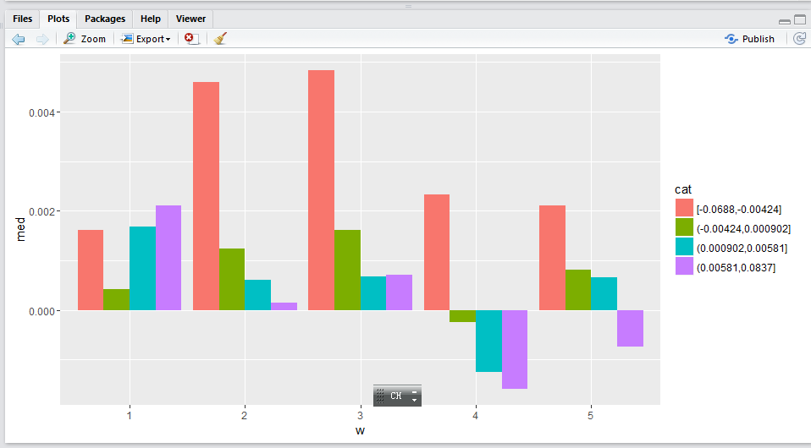

Density:

The following shows that having a lower retPMCOY does help with today's retPMCO.

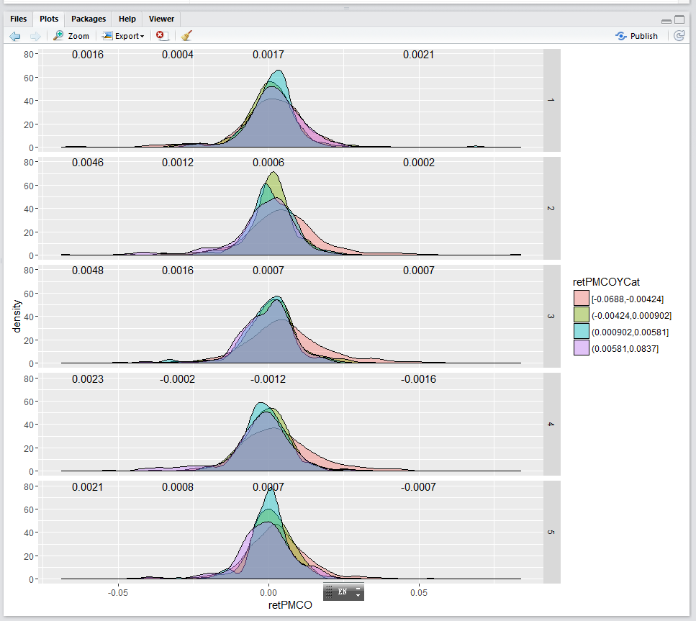

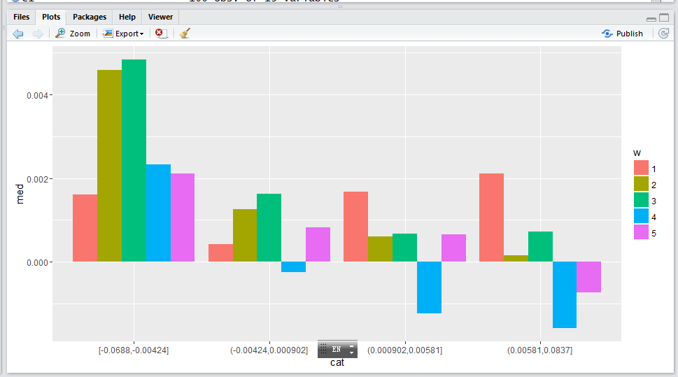

The above graph shows that when T-1 pm was weak, **wed > tue> thu> fri > mon** in terms of strength.

When T-1pm was semi weak, **Wed > tue > fri > mon > 0 > thu.**

When T-1 pm was semi strong**, mon > wed > fri = tue > 0 > thu.**

When T-1 pm was strong, **mon > wed > tue> 0 > thu > fri.**

**For AM:**

lsam <- ifelse(weekday==2 | weekday==4, -1, ifelse(weekday==1 | weekday==3, ifelse(percentileY<0.6, -1, 1), ifelse(percentileY>0.6,-1,1)))

Strategy: based on percentileY. Short on Tue/Thurs AM.

Mon/wed: if percentileY<0.6, short, else long.

Fri: if percentileY>0.6, short, else long.

Cum return on each weekday:

Mon:3.315916

Tue:1.708656

Wed:1.679272

Thu:1.344321

Fri:1.173367

**For PM:**

ls <- ifelse(retPMCOY<0.0035, 1, ifelse(weekday==1 | weekday==3, 1,-1))

res1<-(tail(cumprod(1+retPMCO*ls),1))

If yesterday's PM return < 0.0035, long.

If yesterday was Monday or Wednesday, long.

Else short.

a – cum results.

dfam – am results

f – pmresults.

Keep verifying these results.

**Friday, May 13, 2016**

This week I have been losing money.

Monday morning was a short opportunity, but did not short enough. (In the morning). Only sold 1 lot.

Tuesday PM was strong as expected and I made money on this day.

Wednesday the shorting was too early. All position was cut at around 10:15am. The real shorting point would come in the afternoon (due to Tuesday's strength).

Due to Wednesday's pm weakness, Thursday PM would be a long opportunity. But the short position was carried over to the end of Thursday.

A simple pacf would reveal that

RetPMCOY Threshold optimization: (larger than which, sell, lower than which buy).

mon: 3.64%

tue: 0.0077

wed: 0.0026

Thu: 0.0003

Fri: 0.0032

Time series of thresholds.

Weekly review:

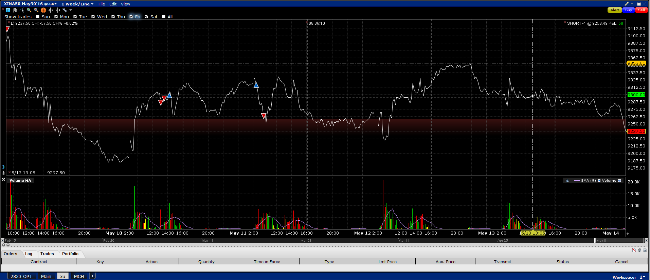

Monday: Entered into this week long 3 lots. Last Friday was weak.